Foundation for Aviation Safety and Tourism
Safety Bulletin No. FAST/SB/20f 2024

NEGOTIATING ADVERSE WEATHER (HELICOPTERS)
PREFACE:
The recent past has witnessed a spurt in Helicopter accidents, that may be attributable to Flight crew, encountering adverse weather enroute, as well as on helipads. Unlike aeroplanes that always operate from airfields, under controlled environment, Helicopters by virtue of their versatility, operate mostly in uncontrolled airspace, over remote areas, over inhospitable and hostile terrain and beyond Radar surveillance most of the time. Hence the responsibility for the conduct of safe commercial operations, rests entirely on the decisions taken by the Flight crew. Therefore, there have been occasions where, some Pilots have become complacent of weather, thus failing to recognize and interpret the deterioration in visibility and associate it, to the dangers of the underlying topography. This safety bulletin is structured to create an awareness among Pilots, of the pitfalls of encountering adverse weather.

Disclaimer:
This document and any related material, are for general training guidance only. The documentation is designed to be used in conjunction with a structured training course and relevant parts of this document, should be used, in accordance with DGCA regulations and company operating procedures. No responsibility is taken for the interpretation and application of the information, contained in this document. Managing the safety of the aircraft, is the sole responsibility of the Pilot-in-command. Any errors, views, comments or suggested changes to this document, are most welcome and encouraged and can be directed to the Chief Ground Instructor, FAST, at fastaviationtraining@gmail.com.

ABBREVIATIONS:
AAIB | Aircraft Accident Investigation Bureau
ADI | Attitude Direction Indicator,
AMSL | Above Mean Sea Level
ASI | Airspeed Indicator
ATC | Air Traffic Control
CAT | Clear Air Turbulence
Cb | Cumulonimbus
CRM | Crew Resource Management
dbZ | Decibel Relative to Z
DCT | Direct
EDR | Eddy Dissipation Rate
EGPWS | Enhanced Ground Proximity Warning System
FMS | Flight Management System
Ft | Feet
GA | Go Around
GPS | Global Positioning System
GRID MORA | Grid Minimum Off-Route Altitude
HDG | Heading
IFR | Instrument Flight Rules
IMD | India Meteorological Department
IIMC | Inadvertent Instrument Meteorological Condition
LNAV | Lateral Navigation
m² | Meters squared
MEL | Minimum Equipment List
METAR | Meteorological Aerodrome Report
MFD | Multi-Function Display
NAV | Navigation
PED | Portable Electronic Device
PF | Pilot Flying
PFD | Primary Flight Display
PM | Pilot Monitoring
RPM | Revolutions per Minute
s³ | Third power of seconds
SIGMET | Significant Meteorological Information
TCAS | Traffic Alert and Collision Avoidance System
VFR | Visual Flight Rules
VNAV | Vertical Navigation

- Introduction
1.1 The vagaries of adverse weather and the understanding that, adverse weather happens to be among the major factors, contributing to many Helicopter accidents, across the country, are widely known. Yet, time and again, we find Pilots knowingly encountering adverse weather and succumbing to accidents and incidents. It is established that, severe turbulence, associated with thunderstorms, convective clouds, lenticular clouds, Cb clouds, clear air turbulence (CAT), wake turbulence, etc; poor Visibility, associated with clouds, mist, fog, hail, rain or sand/dust storms, extreme strong cross winds and wind gusts, near the ground, heavy precipitation, for example heavy rain, hail and snow, Lightning and Thunder, Windshear, Microburst & Macroburst, Blackout conditions encountered during night, Clear air turbulence(CAT), Volcanic ash, etc; all constitute adverse weather.
1.2 Modern technology, with respect to determination of current as well as forecast weather, has come a long way. Today we have great weather applications like ‘WINDY’,’WEATHER & RADAR’, etc, just to name a few, on our fingertips, to augment the weather forecast that are available in the IMD website, ATCs and Airports’ weather department of IMD. Hence weather, both current and forecast, is no longer a grey area or a lesser-known entity, for Pilots. Therefore, it becomes imperative for all Helicopter Pilots, to obtain thorough current weather, forecast weather and METAR, prior to their departure and remain abreast with weather, on their PEDs, with weather and Nav interface application; because, clear sky and light winds now, does not mean that, it will remain that way, during the entire duration of the flight.
2.0 Turbulence over Land and Sea
Helicopters over the years have encountered adverse weather many times and have got out of it safely, when they had sufficient height and terrain clearance to do so, along-with the skill of Pilots to negotiate Adverse weather. It is also a well-established fact that, the intensity and severity of adverse weather, especially Turbulence, encountered over land; is many times more intense and more severe, than that, encountered over sea, due to the following factors: -
(a) Temperature contrast: Land heats up faster than sea, creating a larger temperature difference, between the ground and the air above it. Divergent lateral spread of temperature, due to differing elevation, forestation, mountainous terrain, etc. This contrast fuels stronger updrafts, which can lead to more intense downdrafts.
(b) Moisture content: Land typically has lower moisture levels than sea surfaces, which can lead to more intense evaporation and subsequently, stronger downdrafts.
(c) Friction: Land surfaces have more friction than sea, different topography like mountains, plains, disrupting airflow and differing topography like forest vegetation, cultivation, dry rock, desert, etc creating more turbulent conditions, that can contribute to stronger downdrafts.
(d) Weather systems: Severe weather formations, like thunderstorms, which often produce downdrafts and microbursts/macrobursts, tend to form and intensify over land.
Note-1: It essential to note that, Turbulence can still be severe over sea, especially in areas with high sea surface temperatures or near coastal regions, (convergence zones), where land and sea interactions occur.
3.0 Avoidance is the best Policy It has been driven home multiple times by aviation experts that, the best option to deal with adverse weather, is to avoid it in the first place. This is a practical and viable option, provided Pilots carry out appropriate Safety Risk assessment and apply suitable mitigation measures, in their pre - flight planning stage, to avoid encountering adverse weather. The planning needs to be done on the ground and not in the Air, to achieve safe outcomes. This involves a thorough study of relevant Meteorological Reports like METAR, that gives the accurate location of Convective clouds, like Cbs, Radar weather reports, Trend Forecasts, Wind Shear warnings, Area/Local forecast, Sigmet, Route/Flight Forecast, Satellite images, Doppler weather reports and Synoptic charts. As mentioned above, there are also many useful weather applications, like ‘WINDY’, ‘WEATHER & RADAR’ , etc, just to name a few, that provide various overlays like, Visibility, Low Clouds, Cloud base, Thunderstorms, Rain, Humidity, Turbulence, Wind gusts, Fog, Weather warnings etc. It is an established fact that, Thunderstorm Complexes, i.e. Cumulonimbus (Cb) cells, have strong vertical currents. Aircraft passing within 20 nautical miles horizontally, or less than 5,000 feet above the top, of a Cb cell, may encounter, Clear Air Turbulence or CAT. This happens to be the primary reason, as to why it is advocated that, Helicopters must avoid a CB Cloud, by at least 20 nautical miles,( to avoid recirculation zone of a dissipating CB), as far as possible. It is evident, from past accident case studies, that are attributable to adverse weather that, some Pilots tend to use their weather Radar, more for penetrating adverse weather, rather than to avoid it. This aspect was commented upon, in the AAIB accident investigation report analysis, of BOEING 737-800 aircraft, that encountered severe turbulence, leading to serious injuries to passengers, while operating sector Mumbai – Kolkata, on 07 June 2021. This subtle difference in ideology, in using the weather Radar, may require a paradigm shift, in order to ensure safety of Commercial Air Navigation.

4.0 High Eddy Dissipation Rates (EDR)
4.1 Severe Turbulence, happens to be one of the most critical factors, when it comes to adversely affecting Helicopter Automation and controllability of the Helicopter. Severe Turbulence is typically associated with High Eddy Dissipation Rates (EDR). Eddy Dissipation Rate (EDR), is a measure of the rate at which, turbulent energy is dissipated in the atmosphere. EDR, is a key parameter, in understanding Turbulence and its impact on aircraft, weather and climate. High EDR values indicate increased Turbulence, potentially affecting aircraft stability, controllability and passenger comfort. EDR helps predict weather phenomena, such as Clear air Turbulence (CAT), Thunderstorms and Turbulence associated with mountain waves. Here are some general guidelines on EDR values, corresponding to different Turbulence Levels:
4.2 Turbulence Level thresholds and EDR Values:
EDR Severity Categories:
(i). Low: 0-0.1 m²/s³ (light turbulence)
(ii). Moderate: 0.1-1 m²/s³ (moderate turbulence)
(iii). High: 1-10 m²/s³ (severe turbulence)
(iv). Extremely High: >10 m²/s³ (extreme turbulence)
EDR over Land:
(i). Mountainous regions: 1-10 m²/s³ (severe turbulence)
(ii). Coastal areas: 0.5-5 m²/s³ (moderate to severe turbulence)
(iii). Urban areas: 0.5-3 m²/s³ (moderate turbulence)
(iv). Rural areas: 0.1-2 m²/s³ (light to moderate turbulence)
EDR over Sea:
(i). Open ocean: 0.1-1 m²/s³ (light to moderate turbulence)
(ii). Coastal waters: 0.5-2 m²/s³ (moderate turbulence)
(iii). Tropical cyclone areas: 1-5 m²/s³ (severe turbulence)

Note-2: Please note that, these thresholds are general guidelines and may vary, depending on the Aircraft type and weather conditions. EDR values provide valuable insights, into Turbulence intensity, helping aviation weather forecasting. Pilots should plan routes, to avoid severe turbulent areas. A thorough study and understanding of weather forecasts, help Pilots to prepare themselves, for avoiding severe Turbulence. Screenshot of a sample Turbulence overlay, depicting EDR values and corresponding colour coding, at 5000 ft AMSL, as viewed in ‘WINDY’ weather application on a mobile, is appended below :-

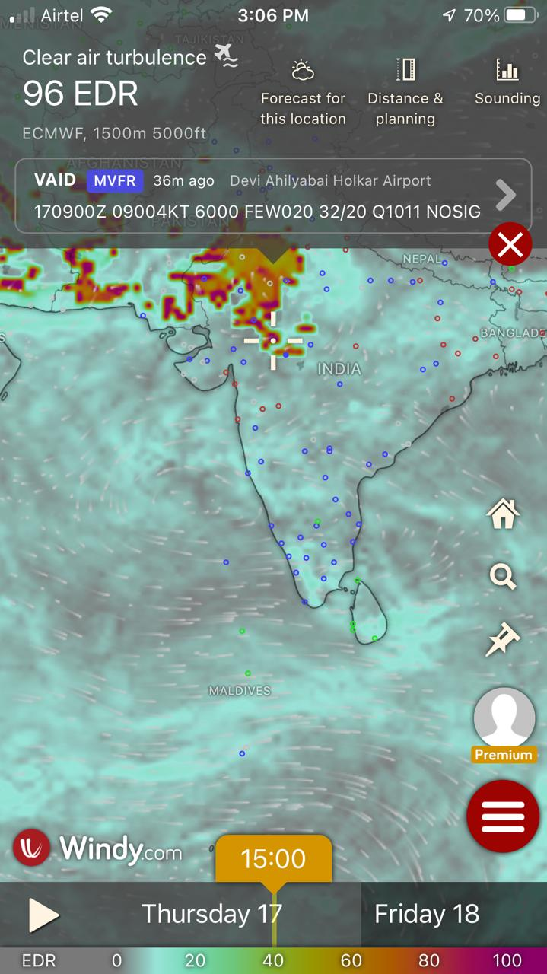
(Figure-1, Screenshot of Turbulence overlay, depicting EDR values)

4.3. Regional Variations of Turbulence:
(i). Mountainous regions:
Turbulence is more severe over hilly and mountainous areas like the Western ghats, Eastern ghats, Northeast India and the Himalayas.
(ii). Coastal areas:
Turbulence can be more intense near coastlines, due to interactions between land and sea breezes.
(iii). Tropical regions:
Turbulence is often more intense over tropical land areas, due to strong convection.
5.0. Heavy to Extreme Precipitation
Like severe Turbulence, Heavy to Extreme Precipitation, like heavy Rain, Snow and Hail, should also be avoided by Pilots. Given below is the logarithmic scale for measuring Radar Reflectivity Factor (dbZ) and the same is generally given in IMD Doppler weather reports: -

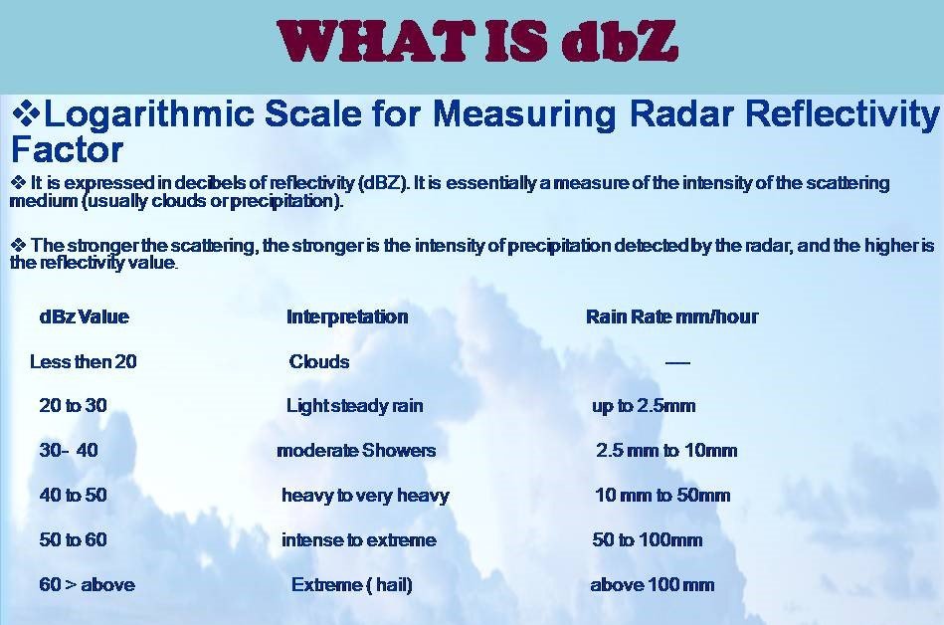
(Figure-2, Logarithmic scale for measuring Radar Reflectivity Factor (dbZ)

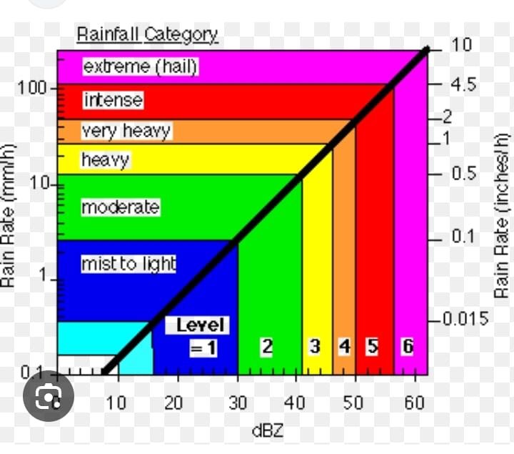
(Figure-3, Rainfall Category with colour coding)

As a rule of thumb, flying in areas, having precipitation at or above 40 dbZ, i.e in areas showing up on the weather radar screen as yellow and above should be avoided.

6.0 Standard/Routine Practices followed in Flight Planning
During Monsoons, the standard/routine practice of flying ‘Direct – Direct’ (DCT), using the GPS, without superimposing the weather along the route, may not be the best option to follow. When it is known that, to recover from any uncontrollable high rate of descent scenario, height above the surface level and terrain clearance, is vital and is the most critical deciding factor. Therefore, it is advisable to maintain a higher Flight level, like the GRID MORA, than maintaining lower Flight levels, when flying under VFR Flight Rules, during monsoon and when flying in adverse weather, as far as possible, keeping in mind other requirements like visibility and surface/ground in sight and maintaining adequate terrain clearance. There may be a need to have additional multiple way points, that should be included in the flight planning; to ensure that, the Helicopter flight path, remains clear of adverse weather, especially severe turbulence, heavy rain, Lightening, Thunderstorm complexes, low clouds, areas of poor visibility, Fog and areas notified and effected by weather warnings. Aviation Implications of Turbulence affect: -
(i). Turbulence forecasting
(ii). Flight planning
(iii). Aircraft design
(iv). Passenger safety

7.0 Helicopter Automation
It is also a well-known fact that, flying in adverse weather, can lead to disengagement/failure of the Helicopter Automation modes, like LNAV/VNAV/Heading/Altitude/Vertical speed etc. However, it should be kept in mind that, such disengagement of the Helicopter Automation, does not necessarily imply an Automation failure because, the Automation will most likely return to normal operation, after regaining control of the Helicopter and the Helicopter re-entering within the Flight envelope required, for the Automation to function appropriately. For example, in most Helicopters, disengagement of the Flight Director is visually displayed, by the disappearance of the cross bars and it’s return to normal operation, is displayed by the re-appearance of the cross bars. Therefore, the key lies in regaining control of the Helicopter, at the earliest and bringing it back within the required flight envelope, for the automation to kick in. It is worth contemplating that, when one is likely to encounter flying in adverse weather, the MEL should never be invoked, for any reasons whatsoever. This is because, the probability of equipment/instrument malfunction/failure is extremely high, when flying in adverse weather. The GA selection on the collective lever, by the PF, is to be familiarised and practised, to facilitate its use in the event of recovery from disorientation.
8.0 SURPRISE AND STARTLE EFFECT
Accident case studies have indicated that, in highly modern and advanced Aircraft, featuring full automation, the disengagement of Automation, will also be accompanied by multiple aural warnings and warning lights, that indicate exceedances of aircraft operating limitations, like RPM, Torque, Rate of descent, Speed, Bank angle, Pitch angle, etc. Sometimes these aural warnings and warning lights, in addition to causing distraction, may also lead to the ramifications of the ‘ SURPRISE AND STARTLE EFFECT ‘, in some Pilots. Startle Effect, is a psychological Human factor and can be termed as an element of Surprise, that can be something happening, that is not expected. For example, like Bird Strikes, Lightning strikes, erroneous indications on the instruments like ADI/ASI/PFD/MFD, erroneous warnings from TCAS/EGPWS, or a sudden disengagement of the Helicopter Automation, sudden loss of all visual cues like when entering IIMC, blackout conditions at night, white out conditions in snow bound areas, etc. It is like a shock, that is going through the body. The initial surprise factor, if not cross-checked with the instruments of the PM, or the standby instruments, may be followed by a startle reflex, that may be a rapid, irrational reflex-like response, to the Startle effect. The startle reflex response, is an involuntary neurological and physiological response, to a sudden-onset of an unexpected event, where normal conscious decision making is bypassed, invariably resulting in action, that may be considered as ‘irrational’, in relation to the circumstances. The startle reflex response, usually seems to affect the Pilot Flying (PF), however, there are no documented cases, of both pilots appearing to have been affected by the startle effect, at the same time, except the known case of Airbus-A330-203 Air France Flight 447 on 01 June 2009, over the Atlantic, between Sao-polo and Paris.

9.0 Consequences, vulnerability and risk of ‘SURPRISE AND STARTLE EFFECT’
The most serious consequences, will be related to the aircraft flight path control and may lead to Loss of Control of the Helicopter. Also, Startle Reflex risk appears to be higher, if the flight situation is 'quiet' rather than 'busy' and primarily when, no visual references exist, for example in IMC or poor visibility conditions, or at night. Startle and surprise effects, can influence pilot performance in many detrimental ways; from mere distraction to inappropriate actions or hasty decision making. Well-learned procedures and skills, can be discarded and substituted by inappropriate reactions, including freezing or over-reacting at the controls. Effective response requires recognition of a startle reflex response, in the affected pilot. The unaffected pilot, will have limited time, to intervene and if necessary, take control, before an upset recovery becomes necessary. This may be difficult, if a significant cockpit authority gradient exists. Even if the pilots have had upset recovery training, successful recovery from Startle effect condition, is not guaranteed.
10.0 SUBSEQUENT EFFECTS OF ‘SURPRISE AND STARTLE EFFECT’
- Loss of Situational Awareness.
- Incorrect Control inputs or sometimes, even giving opposite
Control inputs.
- Fixation.
- Over correction.
- Rough Handling of Controls.
- Forgetting to engage the Helicopter Automation, like the GA button /Flight Director Modes and trying to fly manually or the reverse happening, like overlooking the fact that, the Helicopter automation is slaved to the NAV computers/GPS and trying to manually manoeuvre the Helicopter, overriding the aircraft automation, leading to resistance of hand flying/ destabilization of the Helicopter Flight path.
11.0 MITIGATION MEASURES TO OVERCOME THE RAMIFICATIONS OF ‘SURPRISE AND STARTLE EFFECT‘
Awareness of startle reflex, should be covered in recurrent ground training, including the need to monitor/cross-check the flight instruments of the PM, or the standby flight instruments, when encountering Startle Effect. Like in the case of non-responsive/ disorientation of PF, the PM may have to take over controls, when the PF is found to be affected by the symptoms of ‘SURPRISE AND STARTLE EFFECT ‘. Good coordination of duties between PF and PM and CRM training, should include the importance of rapid and effective response, to any evidence of a startle reflex, in the other pilot, by creating awareness in Pilots, about this peculiar Psychological Human Factor. Pilots should be exposed to sufficient manual flying practice, to maintain confidence in their skills, when these are called for suddenly and unexpectedly. Practicing Startle/Surprise situations in a Simulator, when undergoing Simulator training, like Bird Hits, Lightning strike, erroneous indications on ADI/ASI/PFD/MFD, erroneous warnings from TCAS/EGPWS, encountering gusts/wake turbulence/wind shear while landing/take off, encountering Kites/weather balloons in flight, encountering IIMC/whiteout/blackout conditions, etc, may go a long way in mitigating the ramifications of the ‘SURPRISE AND STARTLE EFFECT’
12.0 Accidents in Which Startle Effect Was Considered a
Factor
Accident Analysis of a number of accidents, that have occurred in the past, where adverse pilot performance following startle, may have contributed to the accident, have been reported in various accident investigation reports. The following are some examples, where startle may have been a contributory factor, for the accident:
Bombardier Q400 Colgan Air Flight 3407 on 12 Feb 2009 over New York, Boeing 737-800 Turkish Airlines Flight 1951on 25 Feb 2009 at Amsterdam Schiphol Airport, Airbus-A330-203 Air France Flight 447 on 01 June 2009 over the Atlantic Ocean, AS 350 B3 Helicopter Flight on 23 Nov 2015 at Katra Jammu, Bombardier CRJ200(Cargo Flight) on 8 January 2016 over Sweden, Sikorsky Helicopter S-76D Flight on 28 JUNE 2022 over Bombay High(Offshore).
While it is difficult to prove startle, as a cause in historical accidents, interviews with startled pilots and qualitative data in flight simulator experiments suggest that, the negative effects of surprise/startle are real and significant in some people. A review of various accidents, such as Turkish Airlines Flight 1951, Air France Flight 447 and Colgan Air Flight 3407 suggest that, Pilot performance was impaired following the onset of an unexpected critical event. Had the Pilots of these aircraft been working with impaired faculties induced by startle, then that would perhaps account for their mishandling of the emergencies encountered.
13.0 Operational Support
13.1 What could be the reason behind commercial Helicopter Pilots, taking highly risky decisions, of taking off and operating from Helipads in uncontrolled airspace, in adverse weather conditions and that too in flight conditions that are even below the minima for IFR, or enter and fly in adverse weather, that endangerers their very lives and the lives of the passengers? There may be no logical or reasoned answer to this; however, there could be a seemingly flawed ideology, noticed amongst Pilots that, failure to undertake any commercial flight, due to weather, is wrongly perceived to be indicative of an underlying weakness or lack of skill/competence in the Pilot. This is because, it has happened many times in the past that, a flight refused by a Pilot on grounds of adverse weather or for any other safety issues, is accepted and carried out by some other Pilot; leading to feelings of remorse and loss of professional pride in the Pilot, who refused to fly the sortie in the first place. However, in rare cases, attitude issues of the Flight Crew, like-Overconfidence/Risk Taking Attitude/Immature Behaviour etc, have also attributed to accidents and incidents, involving adverse weather. The attitudes and norms, that contribute to such accidents/incidents, may have developed over a crew member’s lifetime or, it could also be dependent on the attitude and interpersonal relations, between the Flight Crew and the Supervision over Flight Operations, Operational Support and the Priority and Seriousness accorded to Flight Safety, by the Company. The accident of the Bell-212 Helicopter Flight over Mumbai on 29 Sep 2013, Dauphin N3 Helicopter Flight on 13 JAN 2018 over Bombay High(Offshore) and Sikorsky Helicopter S-76D Flight on 28 JUNE 2022, over Bombay High(Offshore), are striking examples of this scenario. To avoid this dangerous trend, CRM should be embedded in every stage of training, both for Flight Crew and personnel in Managerial positions in Operations, Maintenance personnel and also Ground crew support staff and CRM concepts should be stressed in line operations as well.
13.2 Another supposedly flawed ideology, noticed amongst Pilots is that, some Pilots may feel deep down within that, they may be singled out and hauled up, for the commercial losses incurred by their employer, if they refuse to fly a particular sortie. This wrongly perceived mindset, is clearly displayed in the snag reporting culture, in commercial Helicopter operations, wherein most Helicopter snags, that are perceived as minor, especially with reference to Helicopter automation, like any particular mode (HDG/ALT/LNAV etc), not functioning properly, are reported to maintenance verbally, instead of writing the snags down in the Helicopter Journey Log book. This dangerous practice, was one of the contributory factors, to the Dauphin N3 Helicopter accident on 13 JAN 2018(Offshore) and was also commented upon by the AAIB, in their accident investigation report. The above culture, is expressly typical of Operators, having limited Pilots and limited contracts and/or happen to be struggling commercially. The accident of a Bell-212 Helicopter, over Mumbai on 29 Sep 2013, is a classic example of this pattern and even the AAIB mentioned about this aspect, in their accident investigation report. In some extreme cases, refusal to fly a particular sortie, citing safety issues, has even led to the termination of employment contract, of some Pilots in the past. This strange feeling of culpability that some Pilots feel, while refusing to fly a sortie, on grounds of safety, even without committing any mistake, is unique to the Commercial Aviation Fraternity. When any Pilot gets influenced by this kind of an ideology, it is extremely difficult for the Pilot, to break away from this mindset. However, accidents/incidents can easily be prevented, by providing Pilots with Operational support, i.e. the top Management and those in Supervisory positions in Operations, supporting the decisions that are made by the Pilots, when it comes to refusing to Fly, because of Adverse Weather or for that matter, any safety related issue. The Company Management, can change the above misconceived mindset of Pilots, by reaching out and assuring their Pilots that, the damages incurred by the Company, arising out of refusal to fly any Sortie, due to safety issues, is primarily due to the unavoidable pitfalls in the System and not due to any lack of skill/competence of the Pilots. Providing this assurance to Pilots, by way of Operational support, is vital for the safety of Commercial Air Operations and also to prevent any future unforeseen accidents/incidents, due to adverse weather or due to any grounds of safety.
14.0 Conclusion
The pre-flight preparation must include a visit to www.googleearth.com, or any such similar application and the track(Flight Path), should be marked and viewed in side elevation, to have a grasp of the undulating terrain with obstructions and elevation noted, for superimposing them on the helicopter’s intended flight path. There are no short cuts to thorough Pre – flight planning, in any flying operation. There is a saying that, time spent in reconnaissance, is never lost. The same applies to Pre – flight planning; because well – founded time, spent in Pre – flight planning; has the potential to prevent the Pilots from encountering any surprises en-route and also has the potential, to avert accidents/incidents and thus saving the lives of passengers and Flight Crew.

References:
- Study into Aircraft accident investigation reports
Aircraft accident investigation reports of Bombardier Q400 Colgan Air Flight 3407 on 12 Feb 2009 over New York, Boeing 737-800 Turkish Airlines Flight 1951on 25 Feb 2009 at Amsterdam Schiphol Airport, Airbus-A330-203 Air France Flight 447 on 01 June 2009 over the Atlantic Ocean, Bell-212 Helicopter Flight over Mumbai on 13 Sep 2013, AS 350 B3 Helicopter Flight on 23 Nov 2015 at Katra Jammu, Bombardier CRJ200(Cargo Flight) on 8 January 2016 over Sweden, Dauphin N3 Helicopter Flight on 13 JAN 2018 over Bombay High(Offshore), BOEING 737-800 aircraft Flight while operating sector Mumbai – Kolkata on 07 June 2021, Sirkorsky Helicopter S-76D Flight on 28 JUNE 2022 over Bombay High(Offshore).

- Study into Surprise and Startle Effect Management

- Study into Startle Effect Management for EASA, conducted by Netherlands Aerospace Centre. Disclaimer issued by EASA, is appended below:-

‘This study has been carried out for the European Aviation Safety Agency by an external organization and expresses the opinion of the organization undertaking the study. It is provided for information purposes only and the views expressed in the study have not been adopted, endorsed or in any way approved by the European Aviation Safety Agency. Consequently it should not be relied upon as a statement, as any form of warranty, representation, undertaking, contractual, or other commitment binding in law upon the European Aviation Safety Agency’ .

- Air Pilots - Commercial Air Transport SAFETY BRIEFING NOTE 06, on ‘The Risk of Startle Reflex’.
- FAA Advisory Circular 120-111, on ‘Upset Prevention and Recovery Training’.
- FAA Safety Briefing Magazine March/April 2016, on ‘Surprise-combating the Startle effect’.
- Flight Safety Australia Magazine 2015/08, on ‘Without Warning-The Startle Factor’
- Presentation to the 2014 ICAO LOC-I Meeting, on ‘Managing Startle’

Compiled by Approved by
Capt. Rajendran .J Capt. R. S. Dangi CRM & SGT Facilitator [Helicopters] Chief Ground Instructor FAST

